Getting to the health of healthy food
Food can pose risks. Even healthy food can have an adverse effect on our wellbeing. Risks related to food must be dealt with in a responsible and sophisticated way. The strategy driving the Beneris project has these food safety issues in mind. Not only does it aspire to stimulate awareness of the health benefits of food in a clear and transparent way, but to get to the core of the risks of food we eat every day.


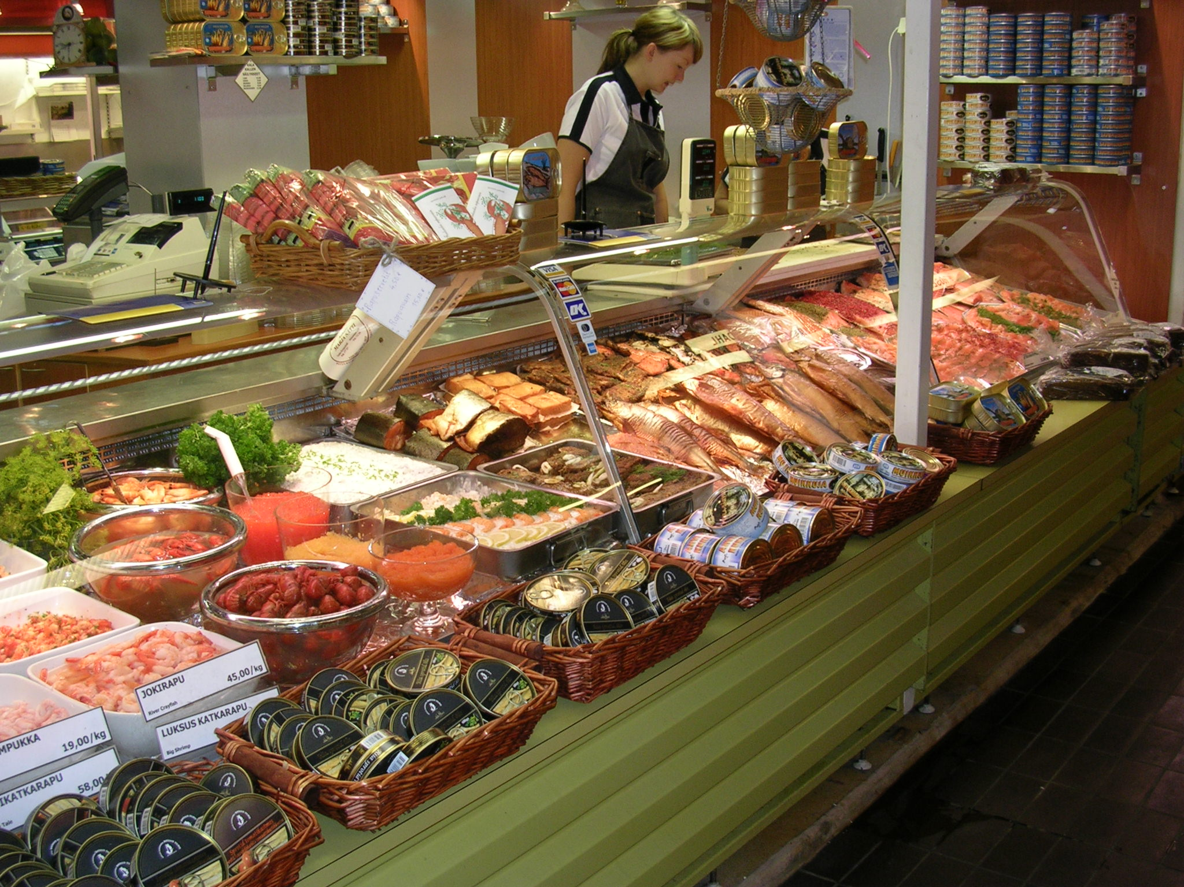

Photo by H. Kiviranta

Achieving the aims
The bold objective of the project is to forge major advancements in food benefit-risk analysis on human health. As such, the project requires highly interdisciplinary work with a range of professionals. Beneris brings together a team of epidemiologists, toxicologists, nutrition scientists, exposure assessors, risk analysts, and authorities from five European countries with crucial access to contacts and data. Importantly, the project's end-users (such as policymakers) will be involved from the outset to facilitate greater collaboration, and to ensure the work has both relevance to science and society.

Employing new and existing methods
The Beneris team will utilize a benefit-risk approach with an iterative top-down means to explore risks of food and its contaminents. In the development of the project's framework methodology, the team will be responsible for reviewing existing scientific evidence as well as identifying, creating and using the systems needed. Health effects of food contaminants and nutrients will be estimated by using new methods integrating epidemiological and toxicological data. In achieving its aim, the Beneris project will also break new ground in the development of specialised methodological tools.

A three-tier work plan
In addition to developing comprehensive methods for analysis, the project is divided into two further areas. A major focus of Beneris is the diverse range of real-life case studies that will be conducted. One of the studies will look at the beneficial and harmful effects of nutrients and pollutants in fish. Another will focus on vegetables in the diet of a specific age group. The dissemination of results through a new Internet interface and other means is also a crucial part of the project.

Working collaboratively


Beneris forms a cluster with another EU project entitled Qalibra (http://www.qalibra.eu/). Although both projects have the same overall aim to improve the analysis of benefits and risks of foods, their areas of focus are very different. Beneris’ objective is to develop new approaches and strategies for analysis as well as disseminating them through the web, while Qalibra is focussed on developing a practical web-based tool for risk assessment. The complementary projects will run separately but with key milestones in their respective strategies for joint meetings and collaborative activities.

Project duration: 42 months, 2006-2009
Contract number: Food-CT-2006-022936
EC Contribution: € 1300000
Website: http://www.beneris.eu/

The consortium contractors and their leaders

➢ National Public Health Institute (KTL), Finland, Dr. Jouni Tuomisto, jouni.tuomisto@ktl.fi, Beneris coordinator
➢ Delft University of Technology (TUDelft), Netherlands, Dr. Roger Cooke, prof., r.m.cooke@ewi.tudelft.nl
➢ Oy Foodfiles Ltd (FFiles), Finland, Henna Karvonen, nutritionist, henna.karvonen@foodfiles.com
➢ Food Safety Authority of Ireland (FSAI), Ireland, Dr. Iona Pratt, ipratt@fsai.ie
➢ Technical University of Denmark (DTU), Denmark, Dr. Ole Ladefoged, ol@food.dtu.dk
➢ Food Safety Authority of Denmark (FVST), Denmark, Dr. Kim Petersen, prof. kimp@fvst.dk
➢ Lendac Ltd (Lendac), Ireland, Don Lehane, computer analyst, dlehane@lendac.ie
➢ Fundación Privada para la Investigación Nutricional (FIN), Spain, Dr. Lluis Serra-Majem, prof. lserra@dcc.ulpgc.es


Benefit-Risk Assessment for Food:
an Iterative Value-of-Information Approach

A Sixth Framework Programme on Food Quality and Safety




Good nutrition through a balanced diet is a universal goal. Simply eating the right food can open the door to a better and healthier way of living. It is, therefore, important for us to understand the consequences of our food choices. Of course, the benefits are promoted loudly and clearly by manufacturers, all too eager to win over our consumer euro in an oversaturated market. But what about the risks of food? How reliable, really, is the information we are getting about the food we eat?


